Nabil Hassan
Leah McCurdy
Nonwestern Art 1317-001
April 19, 2017
The Modern Day Exile
Artwork plays a historic role in comprehending the cultural, political and historical context of nonwestern art. It can consist of visiting a historical art museum and immersing yourself with the artwork or simply by creating your own artwork. What makes art so unique is the flexibility it gives individuals to get out of their comfort zone. With each distinctive artwork comes a variety of different representations and interpretations that viewers can attribute with reality. This can be seen in the artwork titled, "An Exiled Emperor on Okinoshima" (figure 1), where it depicts the theme of social justice. This issue relates to the modern day crisis of the exile of Syrian refugees. Both Emperor Go-Daigo and Syrian refugees in Lebanon and Turkey are all too similar with being exiled from their native countries. Art has the infinite power to trigger an individual's emotions. It also can make viewers escape reality, but also make them relate the artwork they see to social conflicts that inhabit their world. This is the case with this Japanese artwork, as when reading about the history of the Japanese emperor's exile to Okinoshima, it bears great resemblance to the banishment of Syrian refugees in Lebanon and Turkey. Both the asylum seekers and the emperor's exile come under very different circumstances, but both were obligated to leave their native countries. In this paper, I will explore the central theme surrounding the nonwestern artwork "An Exiled Emperor on Okinoshima" (figure 1), which is based on social justice and banishment, while correlating it with the Syrian refugee crisis, and how these themes relate to the cultural, political and historical context of nonwestern art.
Unlike a Western art, Asian paintings viewed from looking right to the left similar to Arabic calligraphy. "An exiled Emperor on Okinoshima" (figure 1), is an example of a shogun art, depicting its control over the emperor recognized as Empire Go-Daigo. On the far right-hand side of figure 1, the empire on his royal white cloak is sitting in a hut looking over the vast sea horizon. Only with his books and koto as his companion, the mystic quality of gold and silver ink suggests the solitude of a distant island and the wealth of the shoguns (Kimbell Art Museum). A visitor most probably a fisherman dressed in a straw cape, appears to have arrived at the left, with a boat along the shore of the hut. The blossoming of the cherry tree close to where the emperor seated depicts the only brightness in an otherwise somber composition reflecting the sense of isolation (Kimbell Art Museum).
"An Exiled Emperor on Okinoshima" (Figure 1), was painted during the Momoyama period. Though originally painted in Japan depicting the power of the shogunate, the painting could today be viewed at Kimbell Museum Collection, In Fort Worth Texas, USA. The artwork was painted around 1600 Century and tells the story of banishment of King Go-Daigo. Emperor Go-Daigo was also known by his personal name Takaharu tried to overthrow the shogunate and restore the monarchy which led to divide the imperial family into two rival factions (Shinoda 1998). Even before his enthronement, Go-Daigo began to plot to overthrow the shogunate and restore the power of the imperial court. In 1331, in the midst of the civil war against the shogunate lead by Hojo Takauji, Go-Daigo was captured by the Kamakura forces while he was trying to flee from Kyoto and sent to exile in the Oki islands in the Sea of Japan. In the artwork "An Exiled Emperor on Okinoshima" (figure 1), many scholars depicts the myth how the boat along the shore was used by empire Go-Daigo to escape from the island and how the fisherman was a loyal supporter of the empire named Takaoki Chidane (Kimbell Art Museum). Though the following year, Go-Daigo was able to escape from his banishment, and upon returning joined forces with the shogun Ashikaga Takauji against the Kamakura forces. In 1333, Takauji took Kyoto, and with the fall of the shogunate, Emperor Go-Daigo began kemmu restoration. The emperor had the plan to re-establish an imperial government, with the samurai in a secondary position (Goble 1996). Go-Daigo foolishness leads to another civil war which leads to the Ashikaga shogunate established by Ashikaga Takauji to gain control and rule over Japan (Shinoda 1998).
Power and greed have been the backbone of a downfall for a country since the ancient time. There is a trend where under Authoritarian leadership there is usually civil unrest, and society will crumble onto itself. The same pattern is seen in Syria, as Syrian people are becoming victimized due to the power struggle among the ISIS, Kurdish forces and Al-Assad regime. Since the year 2011, it is estimated over five million Syrians have fled the country and seek refuge in countries ranging from Turkey, Lebanon, Canada and many others (Ozden 2013). Many have taken shelter in a new country while suffering to get citizenship or work permit in their new home. The Story of Shiaa Sanaa talks about the difficulty her newborn son and family facing every day in a refugee camp in Lebanon (Drake 2016). The camp has over 50,000 newborn babies, yet they cannot be registered as a citizen of Syria or gain citizenship in Lebanon. Many kids do not have access to a proper health care, and like Shiaa Sanaa many other exiled Syrians dream often one day returning to their home country, once all the turmoil has come to rest (Drake 2016). War has separated many family members and seeks a new home. It has been over a year since Sanaa last saw her father and having to go through seeing her neighbor beheaded to act as a warning to speak out against the ISIS regime.
For a time now, Syrians have been seeking refugees in different places of the world. Though Syrians are welcomed in some places, the door has been closed for them in other places. One of the welcoming place for Syrian has been Turkey. Turkey is the home of the largest Syrian refugee camp with over 1.7 million Syrians currently living there as of 2015 (Icduygu 2015). Syrians are registered by the Turkish Disaster and Emergency Management upon their arrival in Turkey. They are helped to meet the daily necessities of life such as assist them to provide shelter, food and clothes and other necessary utilities needed for every day of life (Ozden 2013). Though the Syrian refugees have a home to be called on a temporary basis, very few measures have been taken for a permanent solution. There are very few opportunities to leave the refugee camp, and the irony is most of them are exiled within the camps (Ozden 2013). Although in the last year or so, with refugees registered within the Turkey government has risen to 2.5 million, the Syrian government and the Turkey government are collaborating to grant at the minimum work permit to the people living in Turkey refugee camps currently (Rios 2016). Diaa Ajaj, once a proud owner of a pastry shop in Damascus Syria, is currently working at a pastry shop for half of the salary a Turkish person presently makes. Not being able to get a work permit has hindered many Syrians can live outside the refugee camps, though often are vulnerable to exploitation (Rios 2016).
"An Exiled Emperor on Okinoshima" (figure 1) and Syrian refugees shared the same connection of being exiled due to war. Even though hundreds of years separate the events, both of the events are related to political turmoil. In the artwork, the emperor was an exile in the midst of getting captured by the opposing shogunate army, while Syria has turned into a warzone, with regular conflicts between the Syrian government and terrorist group such as ISIS. Political turmoil had played a major role in Japanese history, with the emperor Go-Daigo losing the second civil war, Japan was ruled by the Ashikaga shogunate afterward the emperor, while Syrian citizens are facing an uncertain future, with thousands of people fleeing to other countries to get away from war.
The artwork and Syrian refugees can be related how it affected them culturally. With the Shogunate ruling shaping up the history of the Japan, the current culture of Syria is affected as many of the artifacts are being destroyed by the ISIS. Emperor taken as a prison and sent to an island as a punishment showed a shift of power and the growing wealth of the shogun. With the emperor supposed to be related to the Japanese God, and had control of military, policy, law, power was shifted to local daimyo (lords who were vassel of the shogun). The shift of ruling among the Japanese showed a cultural shift of how life was under the emperor to a different life and a different ruler how life had become for the Japanese people. For Syrian refugees, their home, the artworks they once cherished are destroyed right in front of their eyes. Many of the cultural aspects of Syrians are being destroyed, whether it is the museum or artifacts, Syrians are paying the price with many choosing to seek refuge in another country.
Exile was a practice which was carried out in Japanese culture, in history two emperors were exiled, while it is a practice still seen in modern society. "An Exiled Emperor on Okinoshima" (figure 1) and Syrian refugees are related by exiled. Though one may argue, the Emperor Go-Daigo had no choice but be banished when captured, Syrian suffering from continuous war, no adequate health care or food available is driving them to seek refuge in another country. Historically the practice of exile still exists, and even in United States of America Edward Snowden seeking refuge in Russia in order not to be trialed for treason if he comes back to America. A practice which can bring a sense of isolation, loneliness, and a feeling of detached from society.
Art is a way of expressing one's inner feeling and can tell a story of what the artist was feeling or the story he/she wanted to convey. "An Exiled Emperor on Okinsoshimo" (figure 1) depicts the story of banishment of Emperor Go-Diango. The artwork tells the story of how he was exiled, and the background color of the artwork helped to illustrate the setting of it. The artwork was related to Syrian refugee of how in both situations they were forced out of their motherland and compelled to live in somewhere else. Through the connection of how they faced ouster from their country due to a political war, how the war affected them culturally, and how separated by hundreds of years they still face the same problem and similar kind of punishment people have to go through.

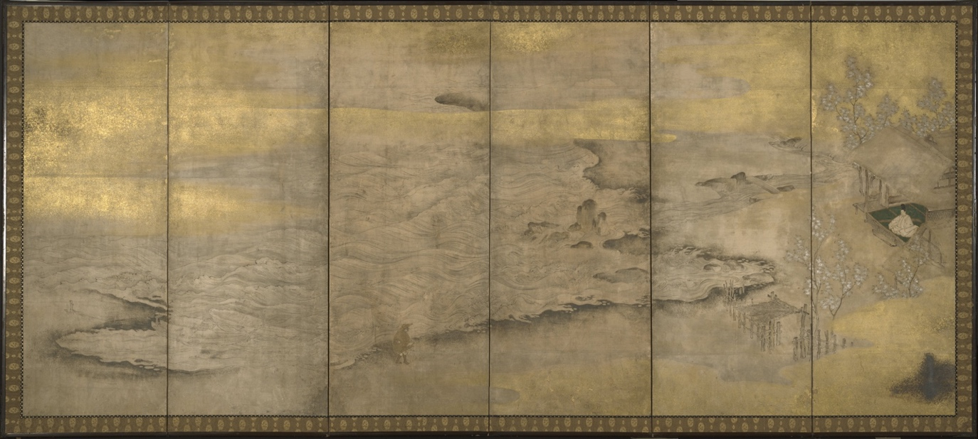
Figure 1 "An Exiled Emperor on Okinoshima" represents an exile of an Emperor in the Okinoshima Island.

Title: "An Exiled Emperor on Okinoshima"
Style/Period: Momoyama Period
Location: Kimbell Museum Collection (Fort Worth,Texas,USA)
Date: 1600 Century

Bibliography

1. "An Exiled Emperor on Okinoshima." Kimbell Art Museum. Web. 19 Apr. 2017.

2. Drake, Matthew. "Syrian Refugee Camp Heartbreak as 50,000 Babies Born in Exile without a Country." Mirror, 12 Mar. 2016. Web. 19 Apr. 2017.
3. Icduygu, Ahmet. "Syrian Refugees in Turkey Long Road Ahead." TranAtlantic Council on Migration, Apr. 2015. Web. 19 Apr. 2017.
4. Ozden, Senay. "Syrian." European University Institute. Migration Policy Center, 07 Mar. 2013. Web. 19 Apr. 2017.
5. Rios, Lorena. "How Turkey's Syrian Refugees Are Getting by." Al-Monitor. N.p., 10 Apr. 2016. Web. 19 Apr. 2017.
6. Shinoda, Minoru. "Go-Daigo Emperor of Japan." Encyclopædia Britannica. Encyclopædia Britannica, Inc., 20 July 1998. Web. 19 Apr. 2017.

